**Assignment-6: Implement a MapReduce program to identify “common friends” among all pairs of users.**

**Chaitanya Sai Nutakki  
AP21110010253**

**GETTING JAR FILE TO ROOT DIRECTORY**

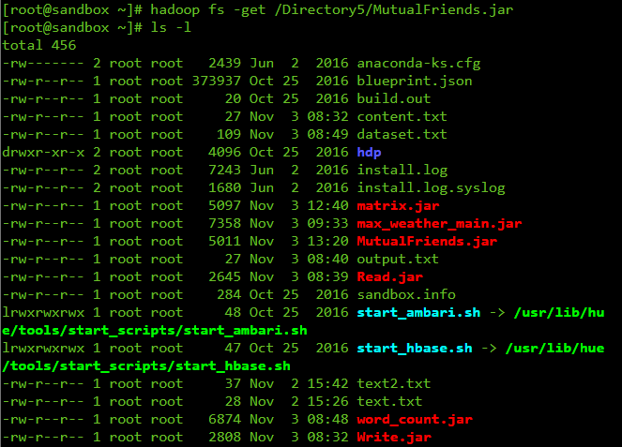

**RUNNING THE MUTUAL FRIENDS JAR FILE**

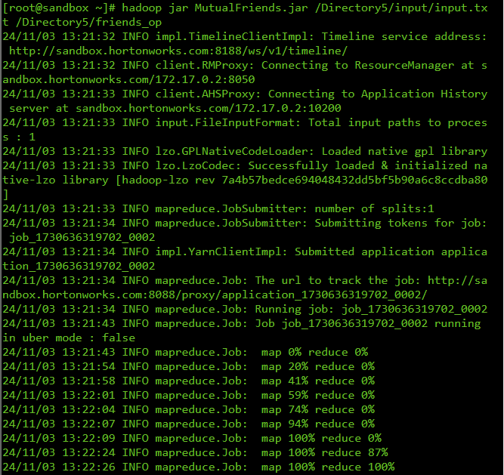

**FILE PREVIEW**

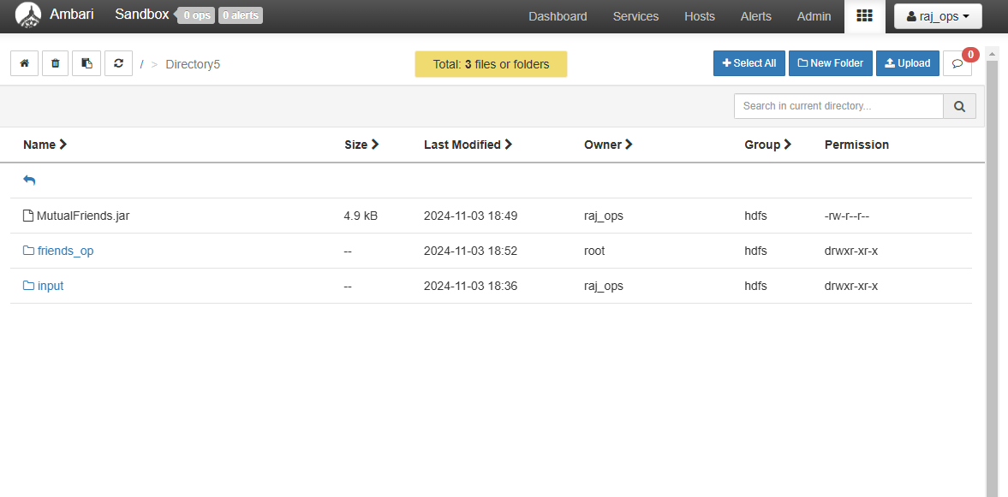

**INPUT TEXT FILE**

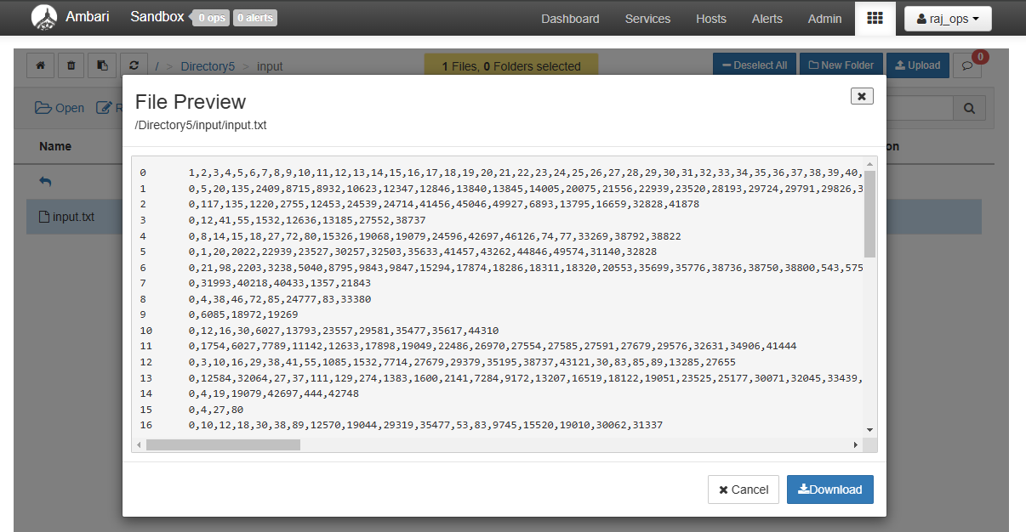

**OUTPUT TEXT FILE**

